Rubik's Cube Solver Project – IUHCM (Vietnam) Collaboration

Team 4

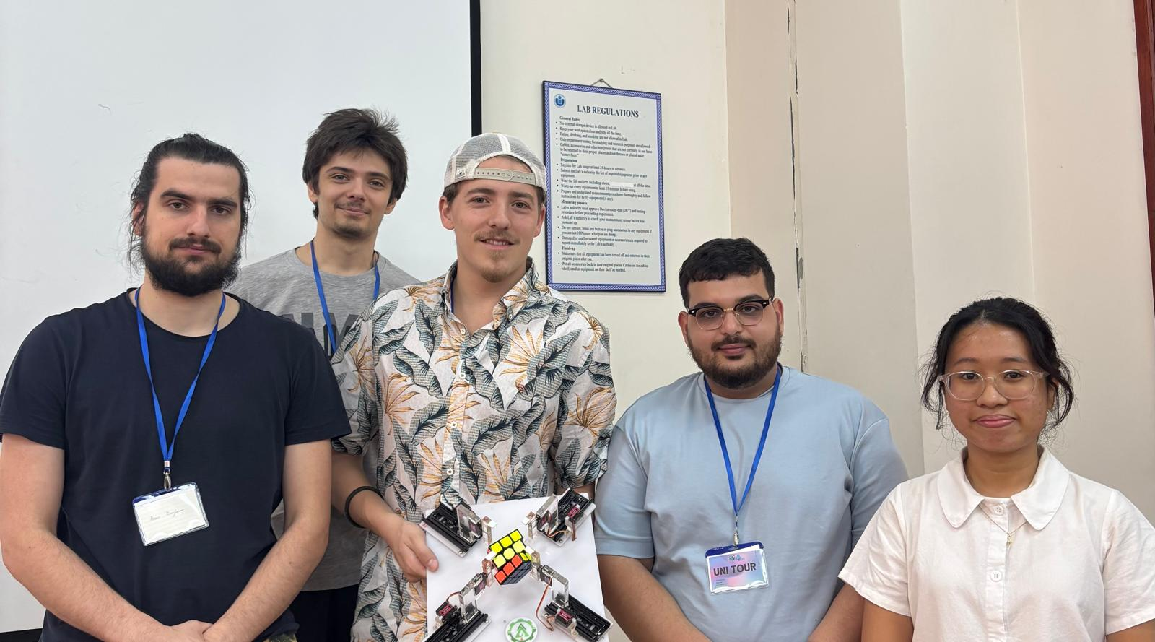



**Presentation :**

Our team, in collaboration with a Vietnamese student named Băng, developed a Rubik’s Cube-solving robot by dividing the work into two specialized teams.

### Team 1: Vision & Virtual Resolution

This team focused on reading the cube’s state and computing the optimal solution. The reading and virtual solving were carried out by Théo, Benjamin, and Băng, with Théo contributing to both teams. The most challenging aspect—accurately reading and solving the cube—was successfully handled by Benjamin, with technical guidance and support from Théo and Băng.

### Team 2: Motion Execution & Optimization

The second team was responsible for translating the solution into physical movements and optimizing the execution. Théo, Amine, Diego, and Băng worked together to refine the robot’s motion. While Amine and Diego optimized delays in the execution process, and at a separate stage, Théo, Diego, and Băng focused on coding the movement sequences to ensure precise and efficient robot motions. Diego then finalized the code and resolved any issues to ensure smooth execution. Additionally, Amine tackled mechanical issues, such as improving hinge stability and repairing a broken spring within the structure.

### Code Conversion & Integration

Théo also played a key role in converting the code developed in Python into a program compatible with the Arduino Nano, which was used to control the robot’s movements. Băng also contributed to coding the movement sequences and cube state reading, further improving the system’s accuracy and efficiency.

Through teamwork and technical expertise, we successfully built a functional and efficient Rubik’s Cube-solving robot. This project highlighted the synergy between software, hardware, and mechanical engineering to achieve a common goal.